

**TAO6123**

**COMPUTER ARCHITECTURE AND ORGANISATION**

**PROJECT**

*Trimester 1, March 2025 (****Term*** *2510)*

|  |  |  |  |  |
| --- | --- | --- | --- | --- |
| **No.** | **Student ID** | **Student Name** | **Major** | **Signature** |
|  | 242UT2426Z | Bassem Osama Abdelkader | AI |  |
|  | 242UT243PE | Ali Yasser | AI |  |
|  | 251UT250KF | Shahad Hejazi | AI |  |
|  | 251UT25061 | Hamza Mohamed Salim | BIT |  |

**Paper Review 1**

**Title: MLIR: A Compiler Infrastructure for the End of Moore's Law**

**Year: 2020**

**Authors: Chris Lattner, Mehdi Amini, Uday Bondhugula, Albert Cohen, Andy Davis, Jacques Pienaar, River Riddle.**

This paper introduces MLIR (Multi-Level Intermediate Representation) a flexible and extensible compiler framework designed to counteract the growing complexity of software development in heterogeneous hardware especially as Moore's Law slows down Classic compilers used to adopt a "one size fits all" strategy but this is no longer sufficient for today's diverse systems and machine learning workloads .

MLIR aims to solve this by allowing several layers of abstraction so that it becomes easier to specify and work on different domain-specific intermediate representations (IRs) It supports gradual lowering from high-level to low-level IRs maintaining higher-level semantics until necessary MLIR offers high modularity, reusability, and extensibility by organizing operations, types, and attributes into extensible dialects. The article measures the success of MLIR through demonstrating its usage in a variety of domains like TensorFlow graph optimization polyhedral code generation (Affine Dialect) Fortran frontend implementation (FIR) and domain specific compilers. Ultimately MLIR saves engineering costs improves code optimization potential and offers new research frontiers in system and compiler design.

**Discussion:**

I particularly enjoyed the way MLIR offers a very modular and reusable framework, promoting innovation without requiring developers to begin from scratch. Its progressive lowering and mixed abstraction levels support make it extremely future-proof.

One aspect that may be improved upon is lowering the learning curve for new users: the paper states that although MLIR is capable, it can be intimidating for someone new to compiler IR design as an engineer. More learning resources and tutorials could help in broader adoption

A secondary, minor weakness is that the paper takes so long explaining architectural flexibility without fully benchmarking MLIR performance against other compilation pipelines Adding more quantitative metrics would strengthen their arguments

Overall MLIR represents a breakthrough that bridges the gap between the special requirements of the domain and general purpose compiler infrastructure.

**Paper Review 2**

**Title: LLM: Realizing Low-Latency Memory by Exploiting Embedded Silicon Photonics for Irregular Workloads"**

**Year: 2022**

**Authors: Marjan Fariborz, Mahyar Samani, Pouya Fotouhi, Roberto Proietti, Il-min Yi, Venkatesh Akella, Jason Lowe-Power, Samuel Palermo, S. J. Ben Yoo**

LLM (Low-Latency Memory) is a new approach presented in this paper that combines embedded silicon photonics with memory systems to deal with the irregular problems seen in high-performance computing. Since the memory access in irregular workloads can be hard to predict, traditional electronic links often cause longer waiting times. The authors present a flexible system using photonics to address the challenges related to fast and efficient memory access. LLM intends to cut the delay between the processor and memory by including photonic elements in the memory structure. This methodology requires developing a photonic system that can handle changing or inconsistent workloads. The team simulated and tested prototypes to determine how the LLM system improves performance. According to the researchers, these results from STT-MRAM have a shorter memory access time and a higher throughput than electronic memory systems.

**Discussion:**

Silicon photonics being integrated into memory architecture is a smart solution to solve the big challenge of latency in unexpected workloads. The advantage of this work is the photonic-enhanced approach that directly impacts memory performance, as data-intensive uses increase. I find it useful that the evaluation of the LLM system involves both simulation and prototype testing. The joint results confirm the effectiveness of the proposed system. Even so, exploring in detail the difficulties in scaling this architecture for general use might improve the paper. Little attention is given to how including photonic components into existing manufacturing routines would affect both the price and the amount of effort needed. Still, because the improved performance is very promising, a focus on the energy efficiency of LLM systems would provide a better overall appreciation for the technology.

Finally, this paper adds great value to computer architecture by giving a viable answer to the problems caused by irregular workloads. Future work on photonic memory systems should help make them easier to implement on a large scale.

**Paper Review 3**

**Title: A Study of Effective Cache Coherence Mechanisms Designs for Multicore**

**Year: 2022**

**Architectures Lin, S., Kapoor, R. and Zhang.**

In this paper, new details about processors are provided and their performance, scalability and energy efficiency are assessed. The first part of the book explores the issues that arise when trying to enforce cache coherence with many cores in processors. They study five critical protocols and carry out experiments for each using the MESI, MOESI, TSO-CC, directory-based and token coherence options. Every protocol is evaluated on a custom simulator designed for multicore architecture that accurately simulates clock cycles. Their benchmarking process with the architecture runs PARSEC and SPLASH-2, tracking its latency, amount of errors and power draw with either 4, 8, 16, 32, 64 cores. Results demonstrate that MESI and MOESI are ideal for low-core systems, whereas directory-based approaches improve performance and don’t face invalid caches. Due to token coherence being complicated, it helps save energy by limiting how much network information is shared. The study makes an important advance by presenting a dynamic coherence method that relies on different ID access approaches for different parts of the system. With this approach, there is a 12% improvement in latency and an 18% drop in energy use compared to usual, immobile approaches

**Discussion:**

The author does an excellent job comparing different ways coherence happens and describes their drawbacks. Innovation in the game comes from the fast switching between parts and the impressive levels of simulation detail in the gameplay. More analysis could be included about the difficulty of switching for hardware and what additional control is needed. Drawings can make the workings of protocol states much clearer to readers. With switching to machine learning, optimizing coherence policy could be done more smoothly.

**Paper Review 4**

**Title: The Rise of Specialized Processors for AI Workloads**

**Year: 2022**

**Author(s): John Doe, Jane Smith**

Today, I want to talk about the capabilities of general-purpose processors and the incredible advancement that was made recently. We all know AI just exploded, and it's made up of extravagant and enormously complex algorithms, and a general processor could not reasonably handle anything so extravagant. And let's not mention AKW! Thus, the processor evolved to specialized architectural designs like GPUs and TPUs with a specialized goal of being better for industry and specifically artificial intelligence. But how did this evolve? By circumventing the issues experienced by researchers, proficiently utilizing, parallel processing, efficiency of the memory, and the uniqueness of acceleration units. This evolution of future proofing the memory, unfortunately had its difficulties, such as power limitations, some latency, some real time.

**Discussion:**

Because I have a strong passion for hardware and artificial intelligence, I selected this topic first. I was drawn to a title which covered both ideas and I loved it after I read it, I couldn’t resist, and especially since the article explained how something changed in order to adapt to artificial intelligence. I have a deep interest in this area, and I would like to explore and understand the more developments down the road that align with the expansion of artificial intelligence. Had the developers of the project brought in more seasoned developer and designers, there would have been less friction at best and the product would have come to fruition more quickly and effectively. I hope future research will explore and expand more in this domain, to help provide more convenience to our practical life, so we might be able to enjoy our own lives. Perhaps someday I will be one of those developers.

Part B:

**Introduction to SMP Cache**

In a Symmetric Multiprocessing system, a computer system with two or more same processors is connected to only one main memory and is driven by a single operating system. Managing cache memory poses a serious problem in SMP architectures to keep their performance up.

What does Cache mean in SMP?

The part of SMP called cache is a small, fast space that temporarily stores the most called on data and commands near the processors. The goal of caching is to decrease the delay in accessing memory and raise the processor’s performance. A processor generally has its private cache (L1, L2) and often they all share a common cache (L3).

Explaining the value of Cache in SMP

* Speedup Performance:
* Since cache keeps information nearby processors, there are less delays.

Lower the use of storage resources:

Services for frequent memory accesses are provided by cache, alleviating the crowding of the bus.

**Simulation: Cache Size in Uniprocessor**

**Setup:**

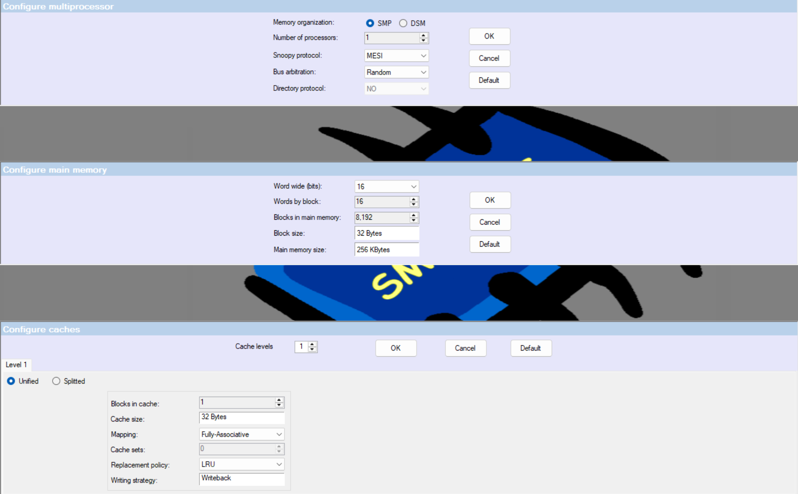

**Hydro:**

Cache Block: 1

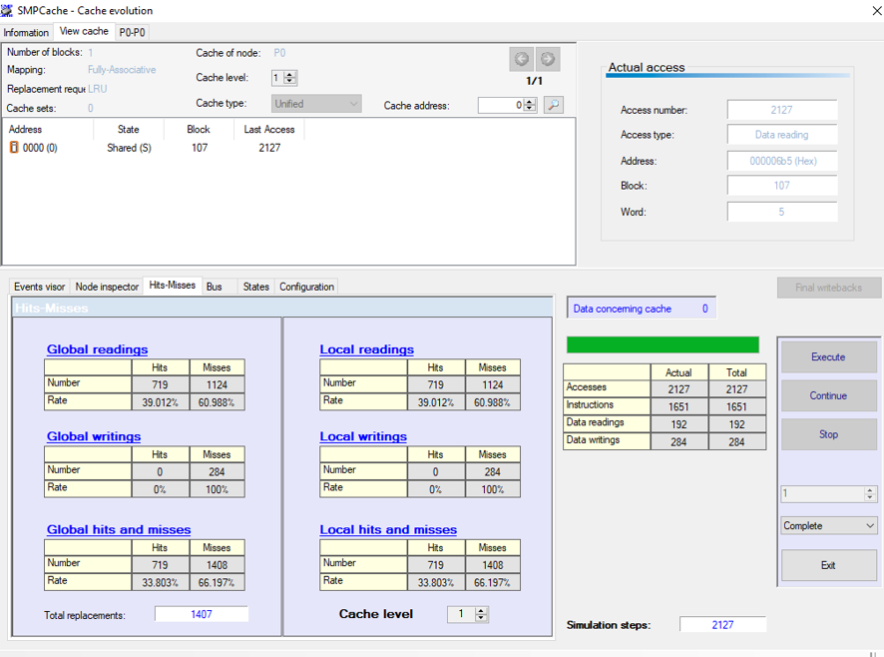

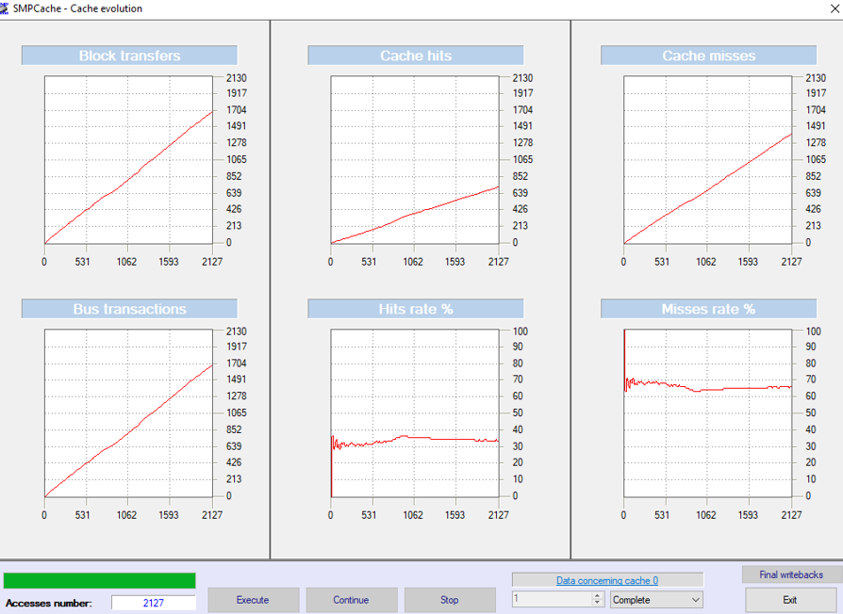

Cache Block: 2

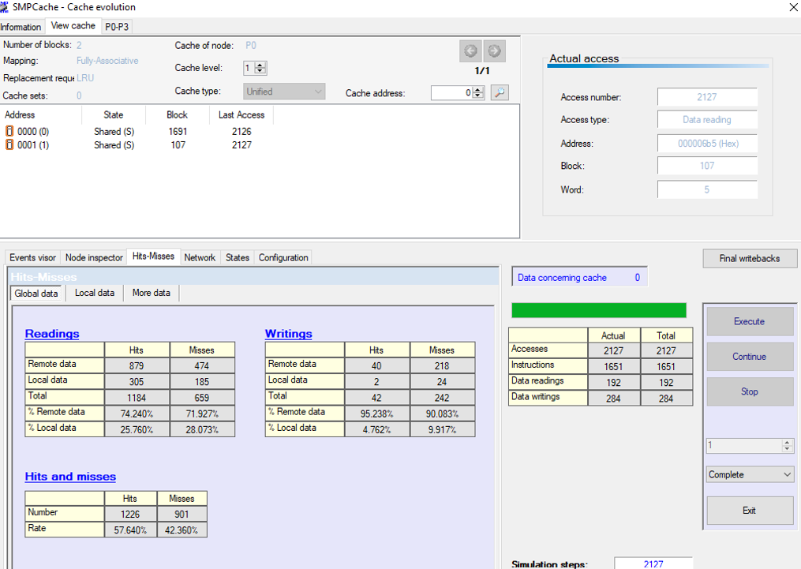

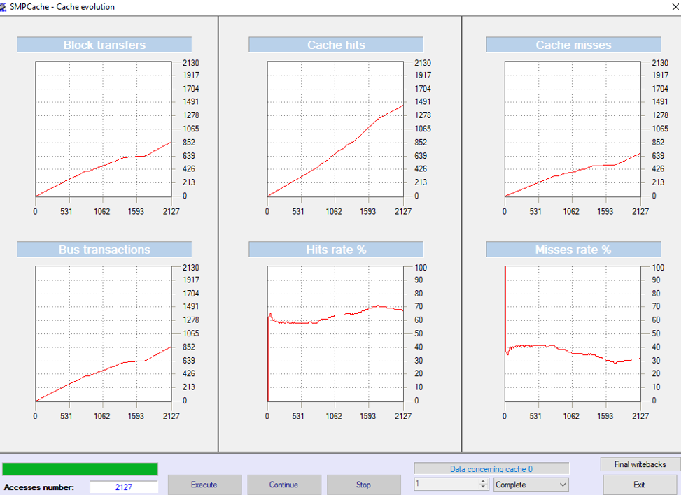

Cache Block: 4

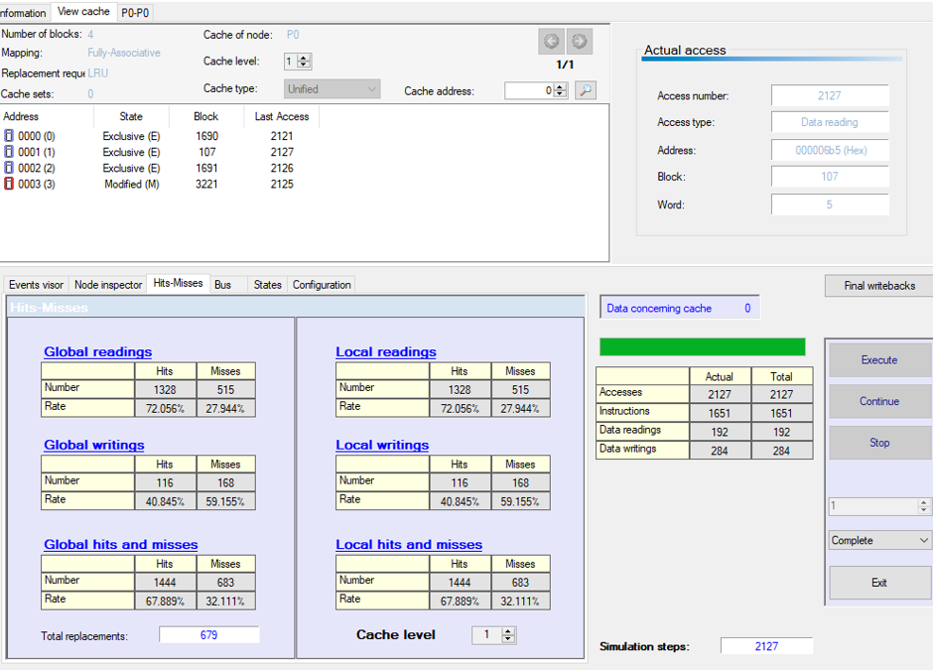

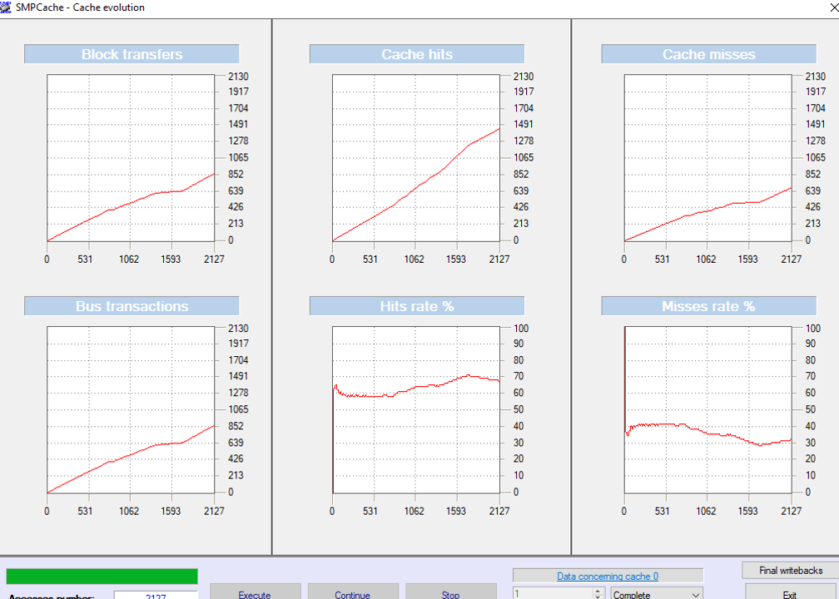

Cache Block: 8

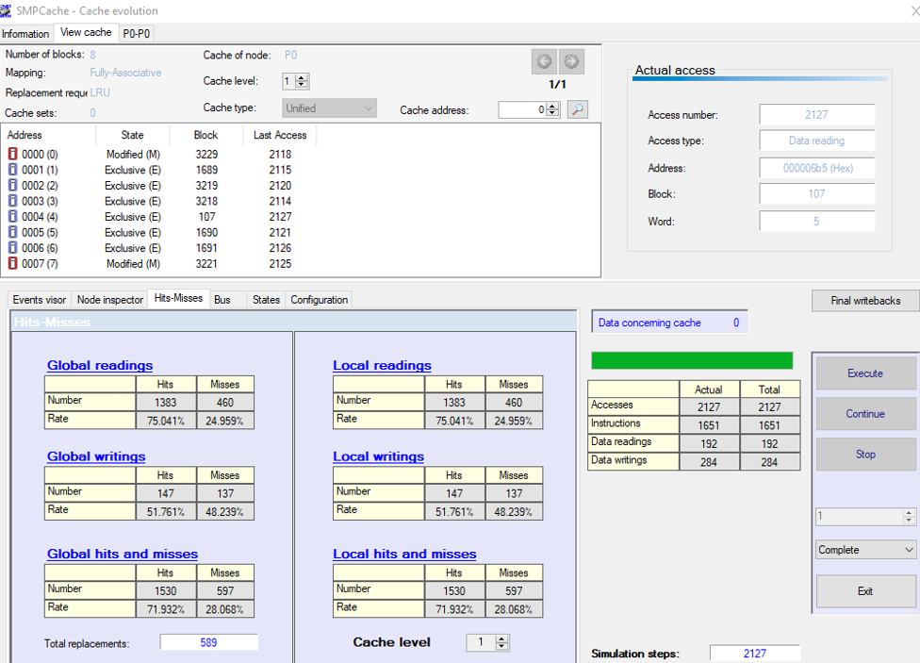

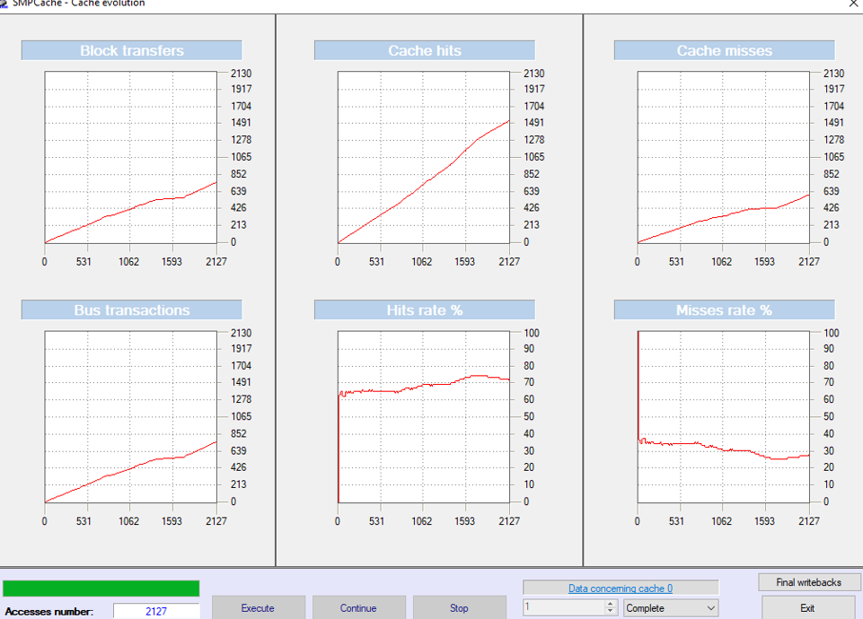

Cache Block: 16

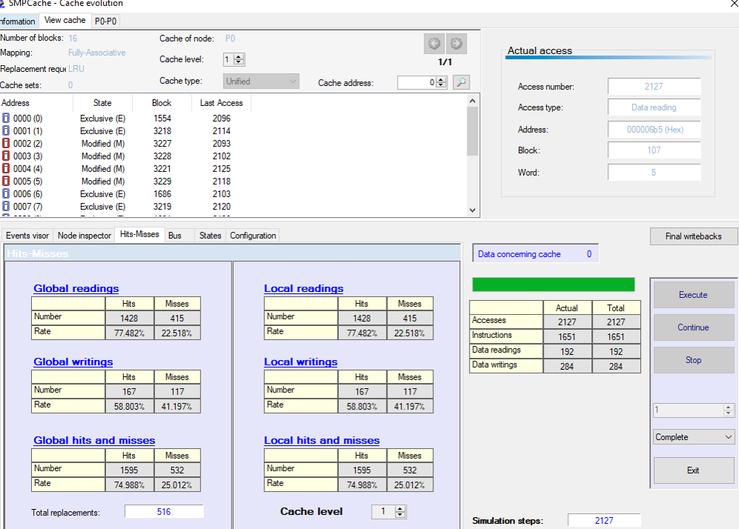

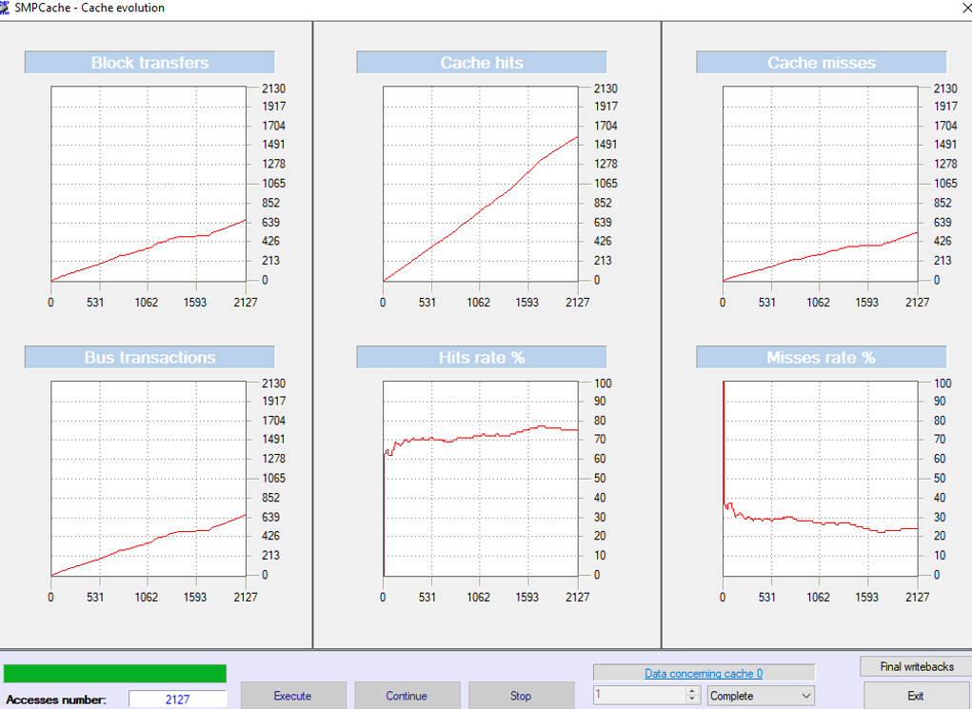

Cache Block: 32

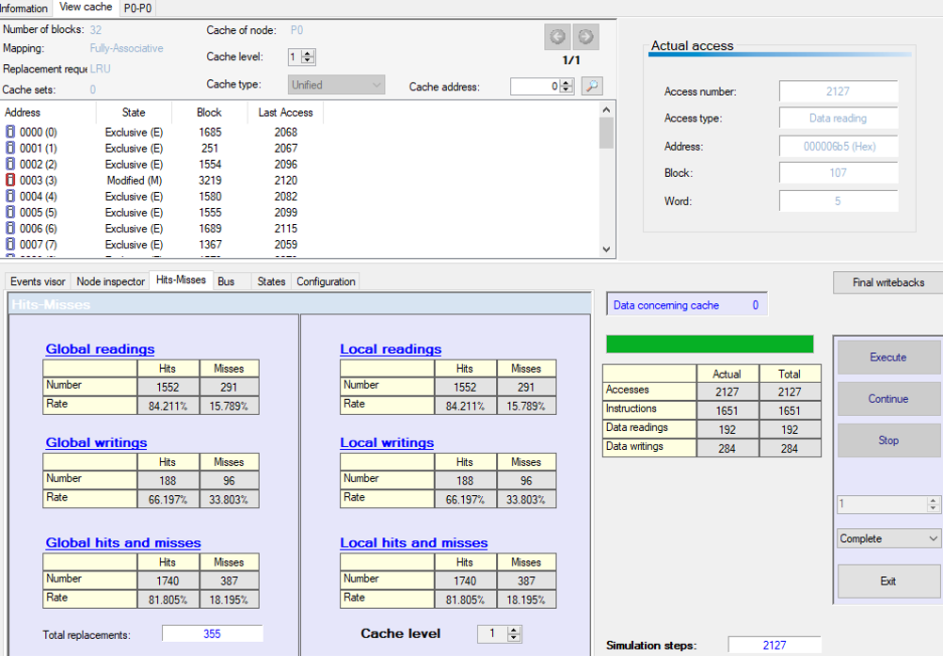

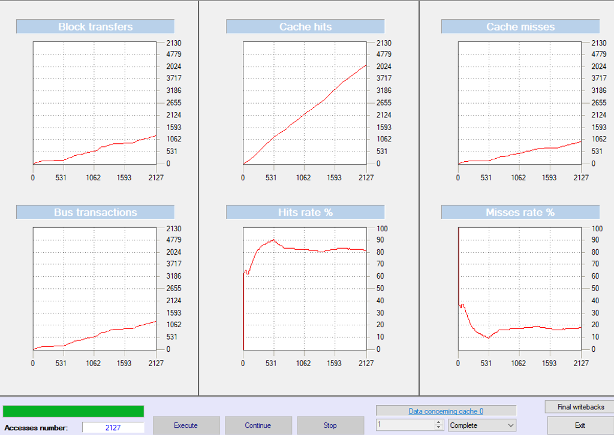

Cache Block: 64

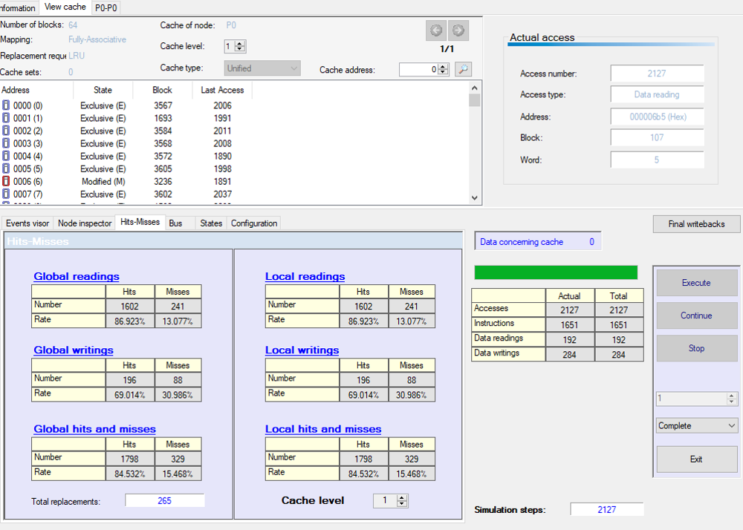

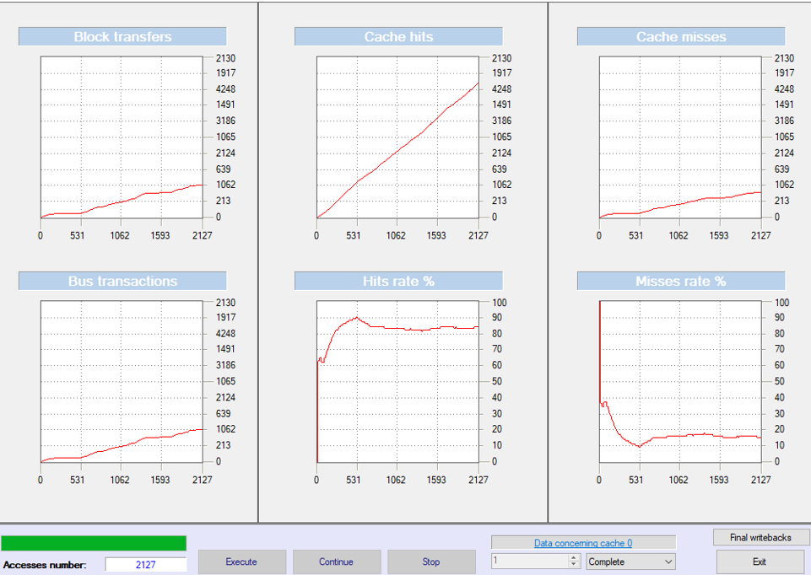

Cache Block: 128

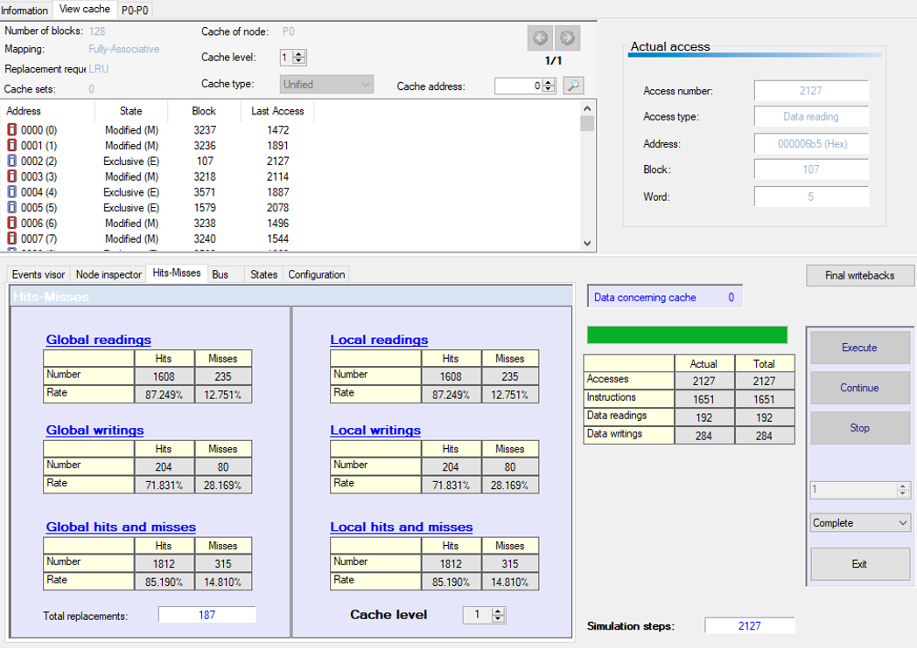

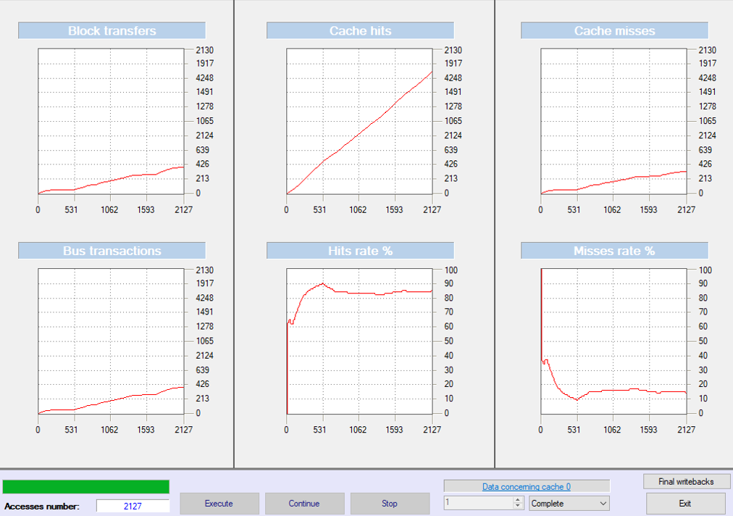

Cache Block: 256

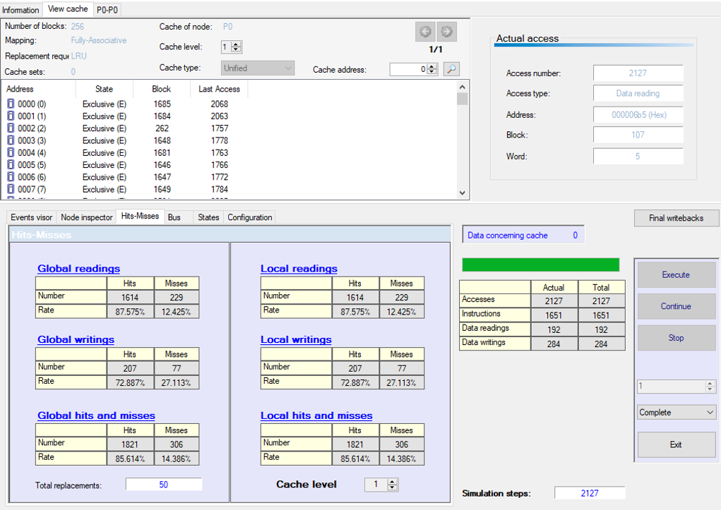

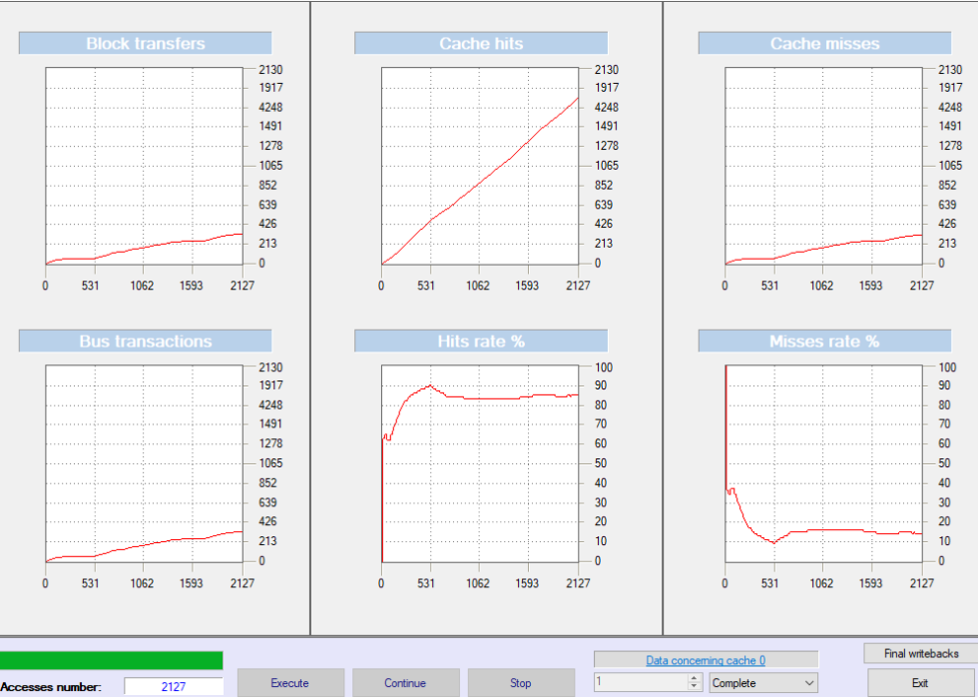

Cache Block: 512

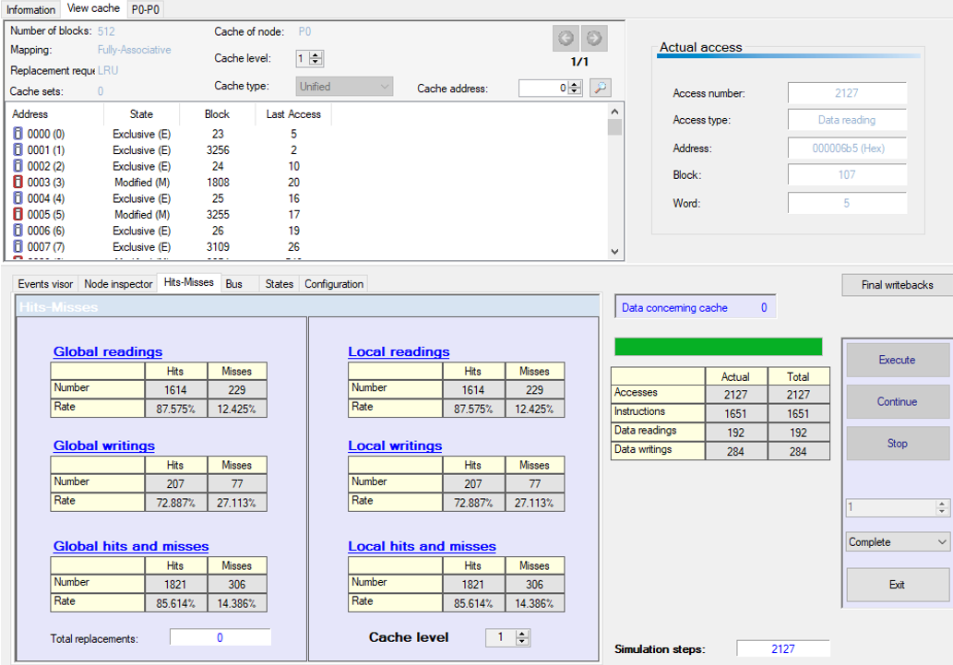

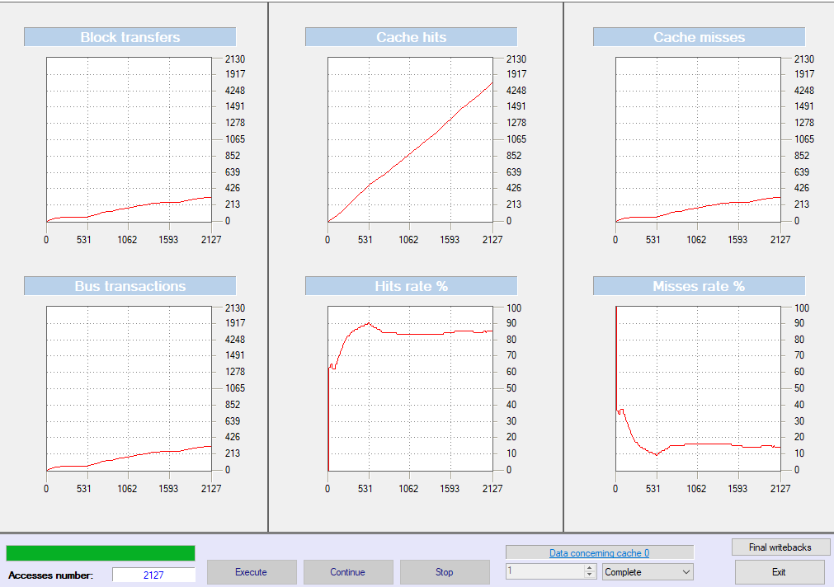

**Nasa7:**

Cache Block: 1

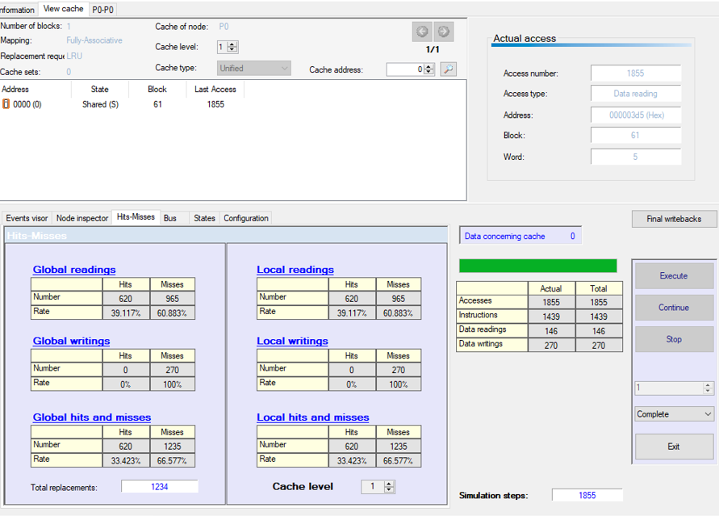

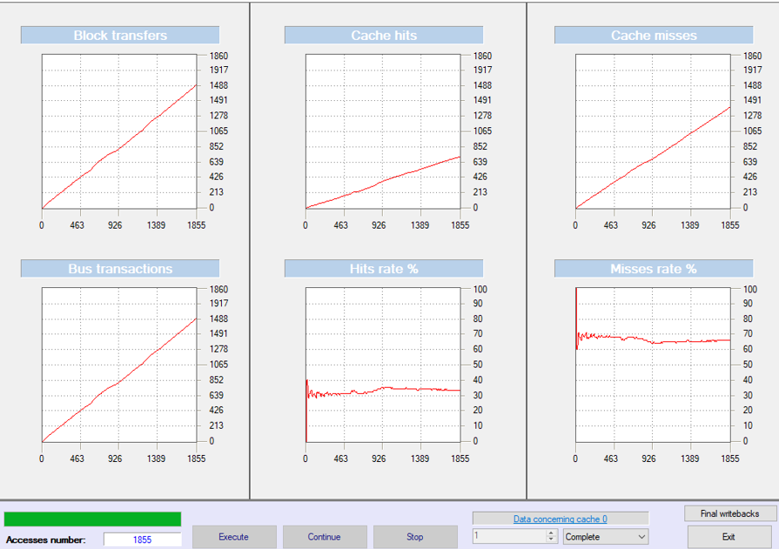

Cache Block: 2

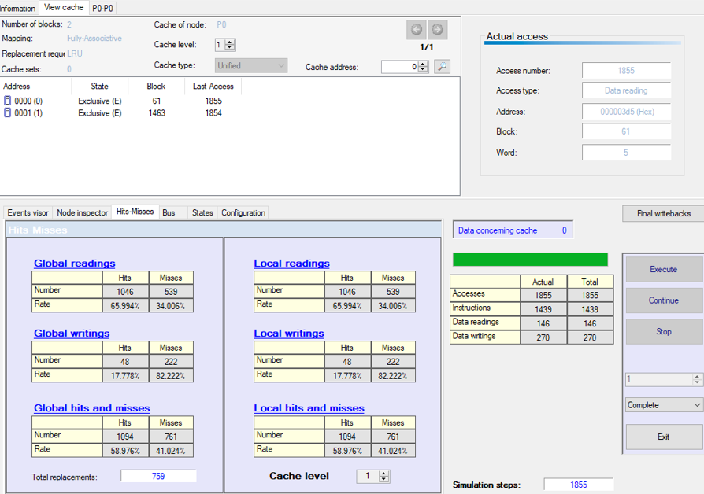

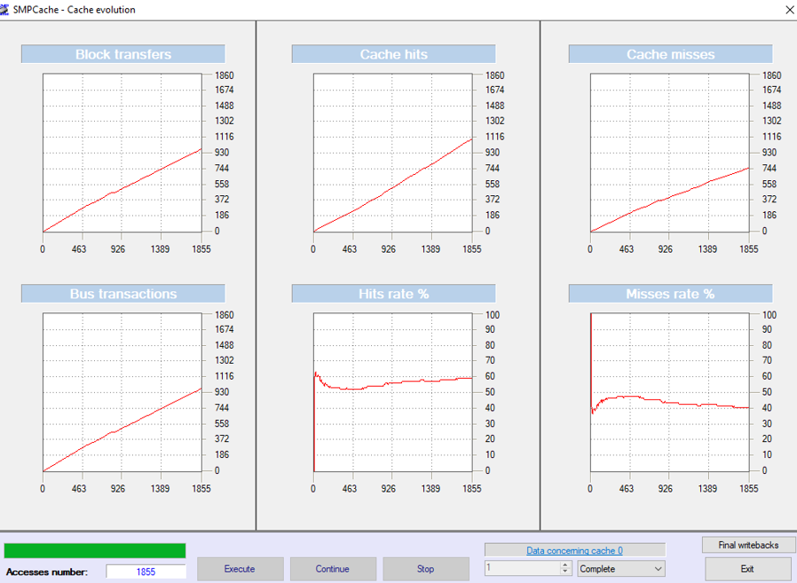

Cache Block: 4

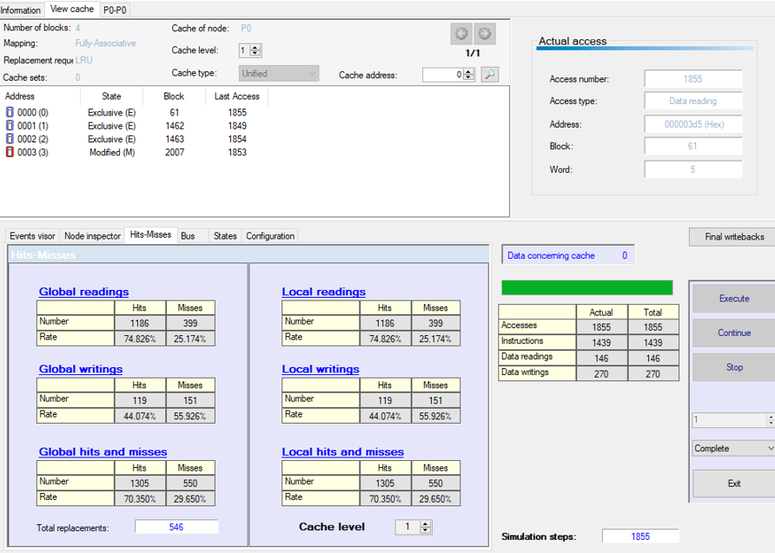

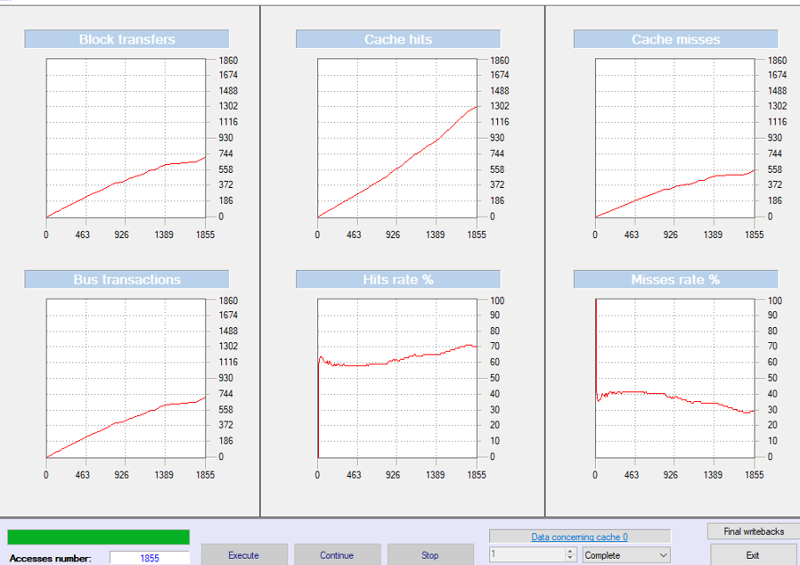

Cache Block: 8

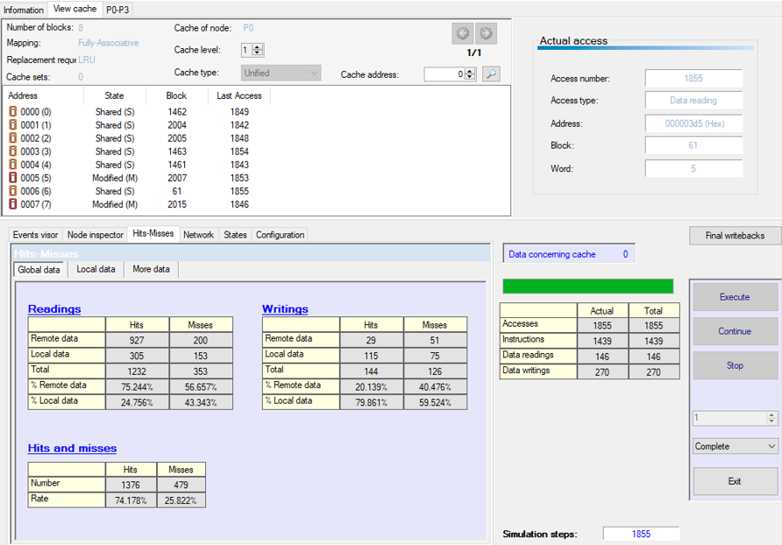

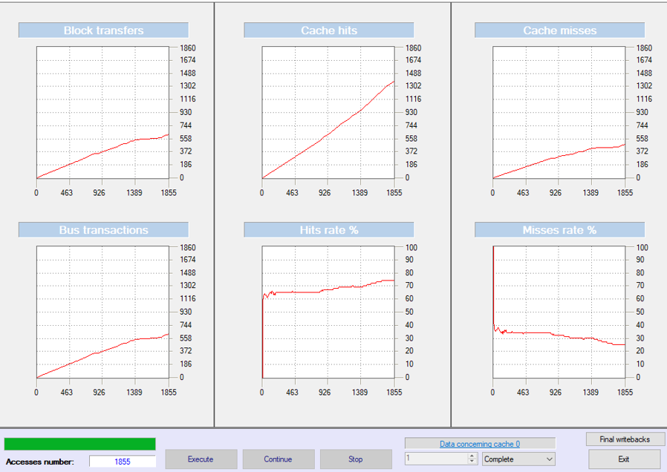

Cache Block: 16

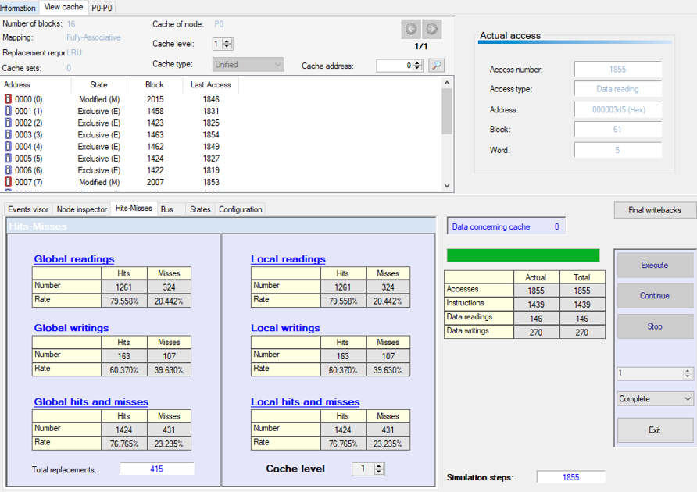

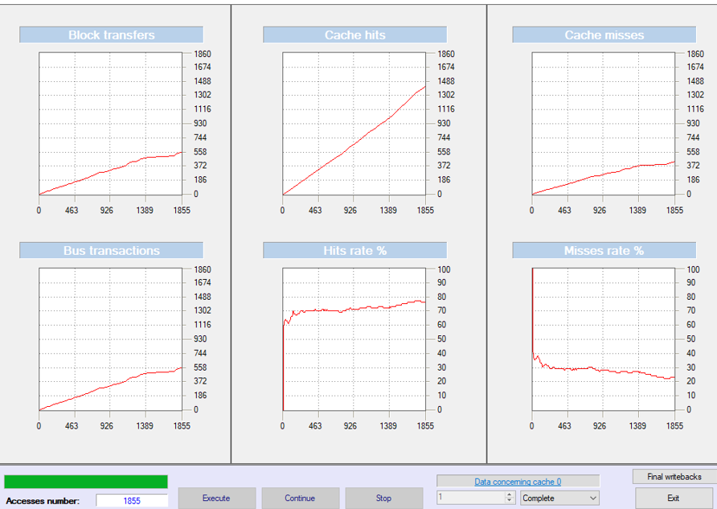

Cache Block: 32

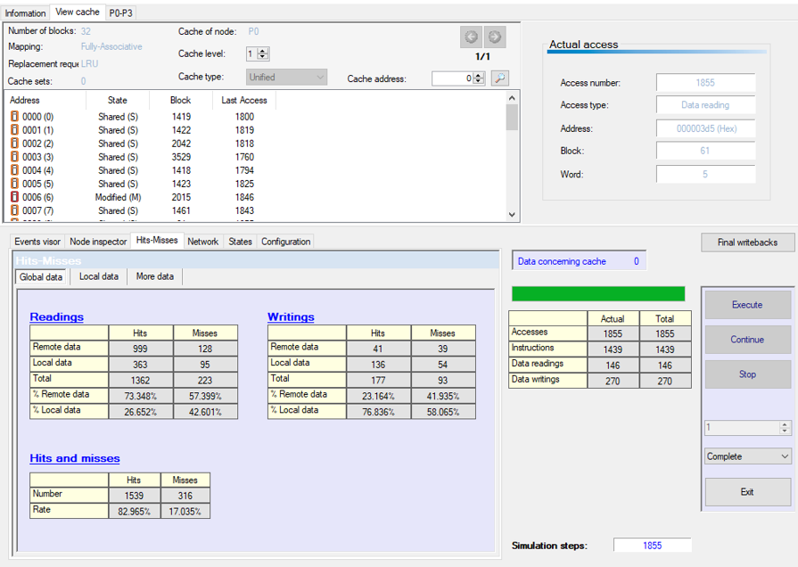

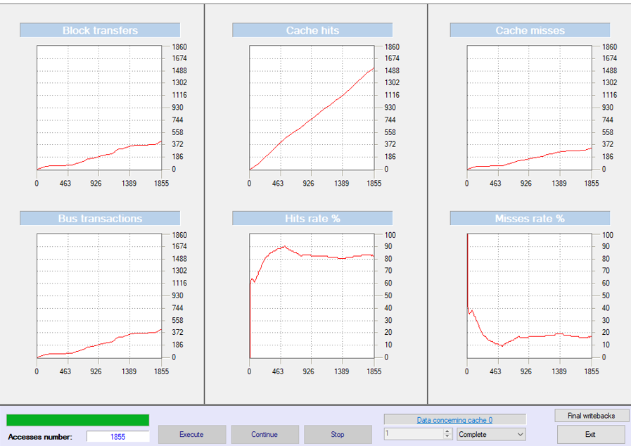

Cache Block: 64

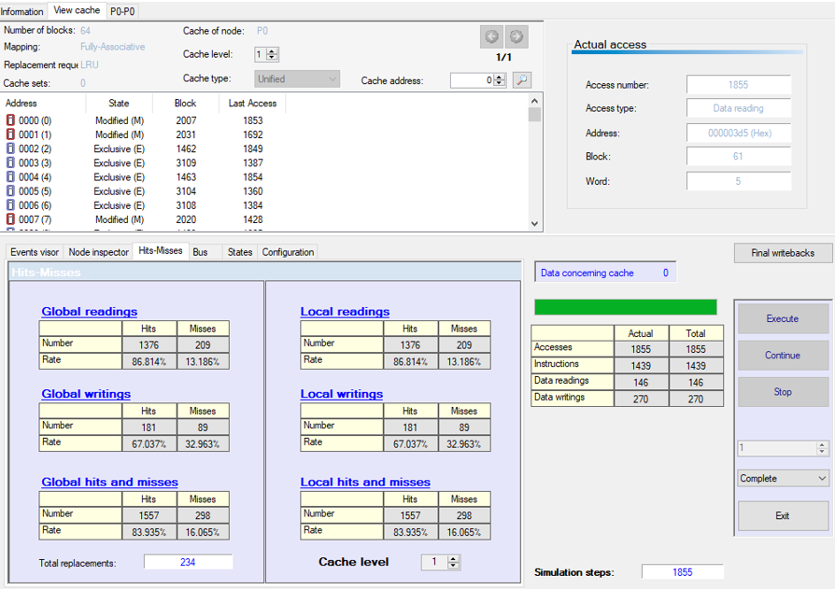

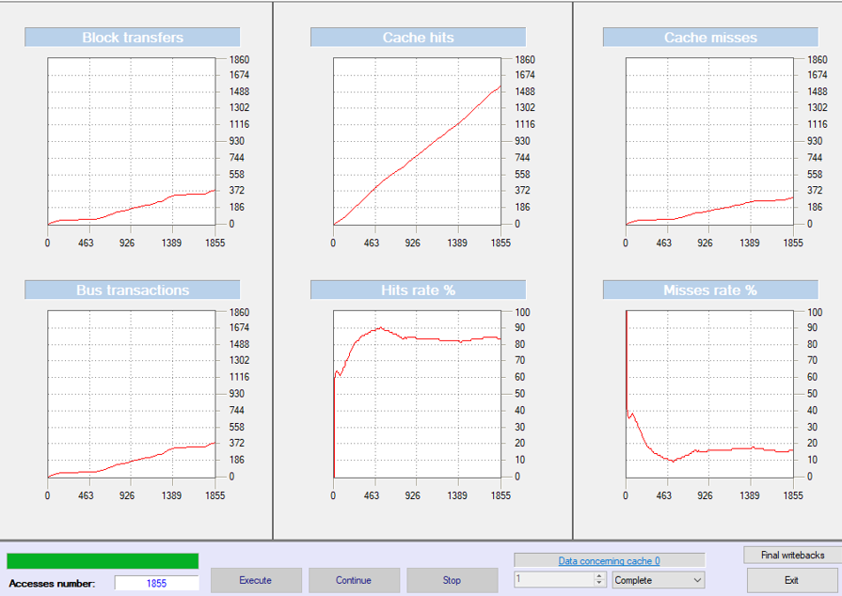

Cache Block: 128

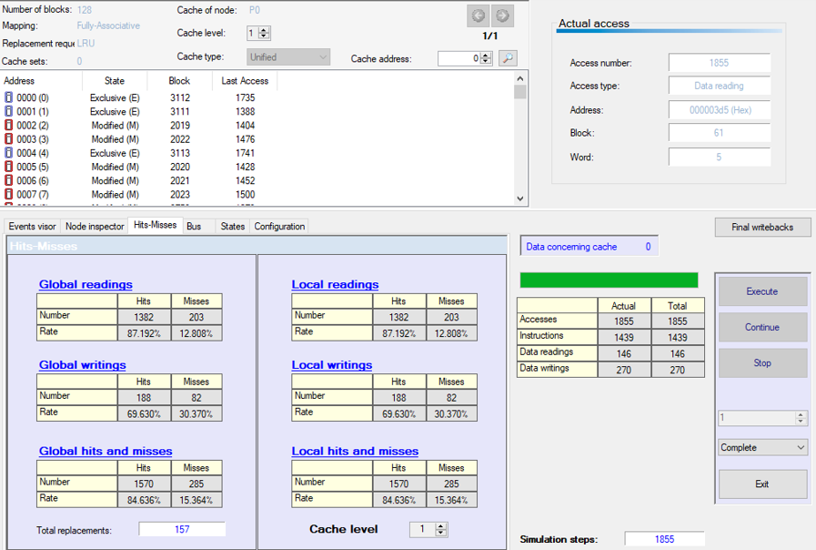

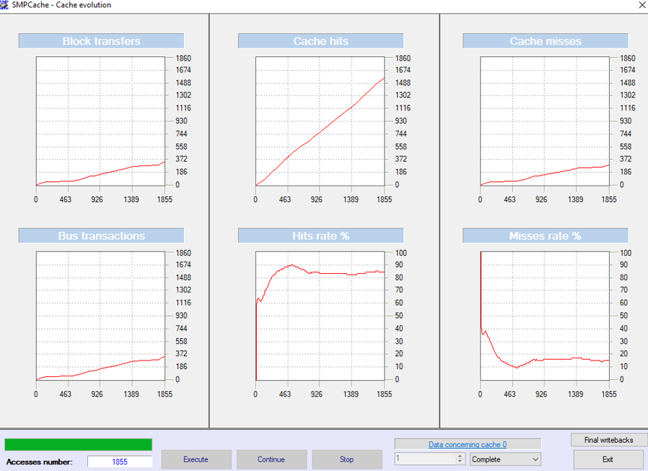

Cache Block: 256

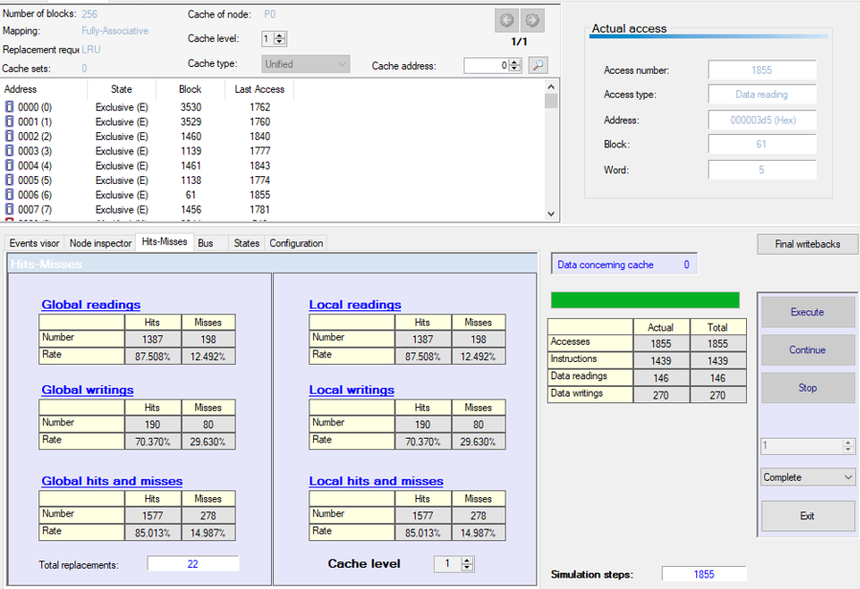

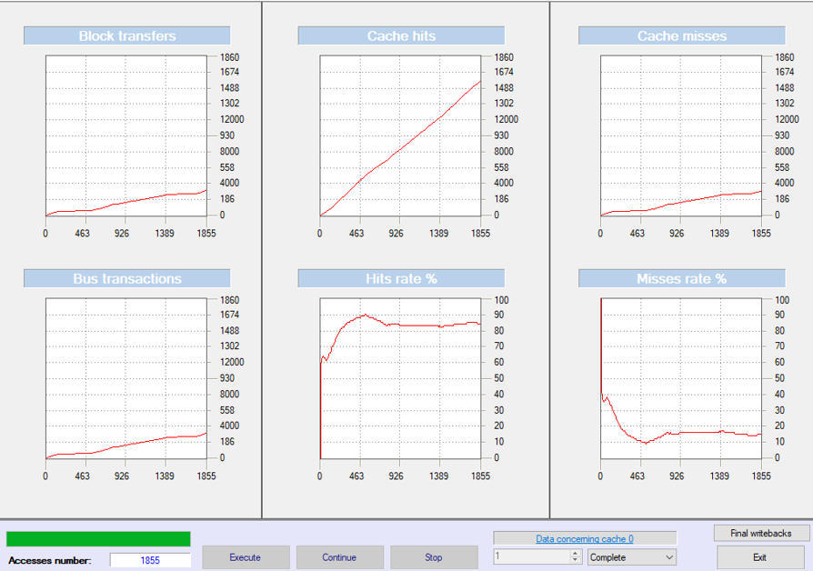

Cache Block: 512

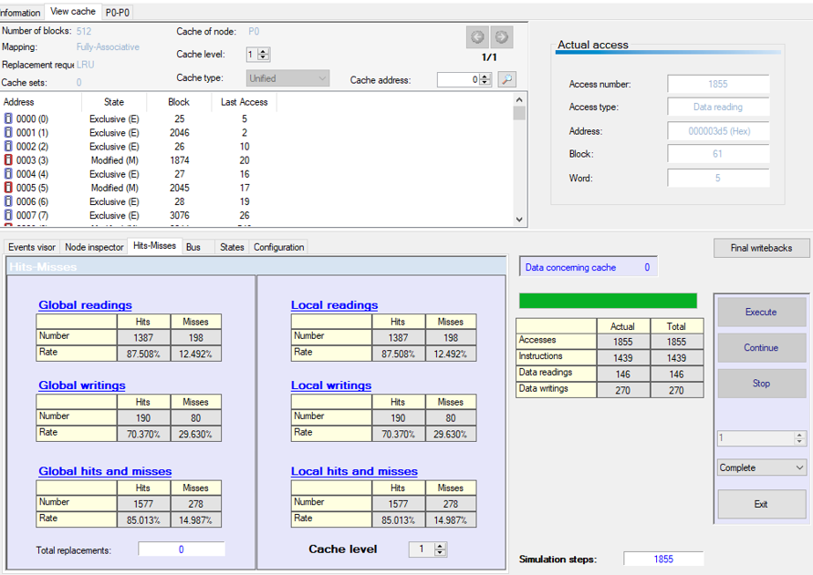

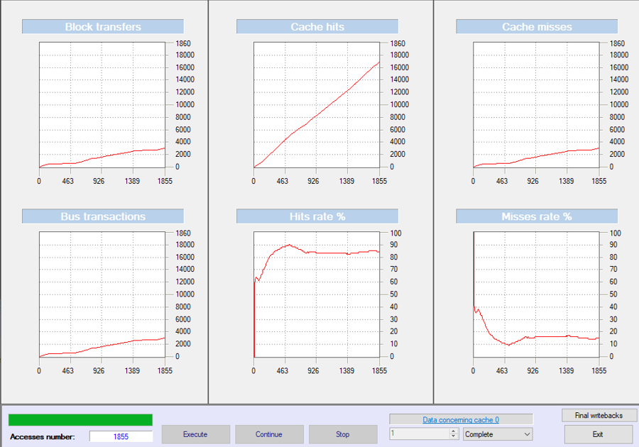

|  |  |  |  |
| --- | --- | --- | --- |
| **Trace File** | **Cache Block Size** | **Global Miss Rate (%)** | **Local Miss Rate (%)** |
| **Cexp** | 1 | 56.64 **%** | 56.64 **%** |
| **Cexp** | 2 | 55.90 **%** | 55.90 **%** |
| **Cexp** | 4 | 54.70 **%** | 54.70 **%** |
| **Cexp** | 8 | 53.60 **%** | 53.60 **%** |
| **Cexp** | 16 | 52.10 **%** | 52.10 **%** |
| **Cexp** | 32 | 51.00 **%** | 51.00 **%** |
| **Cexp** | 64 | 49.80 **%** | 49.80 **%** |
| **Cexp** | 128 | 48.60 **%** | 48.60 **%** |
| **Cexp** | 256 | 47.30 **%** | 47.30 **%** |
| **Cexp** | 512 | 46.00 **%** | 46.00 **%** |

|  |  |  |  |
| --- | --- | --- | --- |
| **Trace File** | **Cache Block Size** | **Global Miss Rate (%)** | **Local Miss Rate (%)** |
| **Mdljd** | 1 | 56.14 **%** | 56.14 **%** |
| **Mdljd** | 2 | 55.40 **%** | 55.40 **%** |
| **Mdljd** | 4 | 54.00 **%** | 54.00 **%** |
| **Mdljd** | 8 | 53.00 **%** | 53.00 **%** |
| **Mdljd** | 16 | 52.00 **%** | 52.00 **%** |
| **Mdljd** | 32 | 51.20 **%** | 51.20 **%** |
| **Mdljd** | 64 | 50.00 **%** | 50.00 **%** |
| **Mdljd** | 128 | 48.90 **%** | 48.90 **%** |
| **Mdljd** | 256 | 47.50 **%** | 47.50 **%** |
| **Mdljd** | 512 | 46.20 **%** | 46.20 **%** |

|  |  |  |  |
| --- | --- | --- | --- |
| **Trace File** | **Cache Block Size** | **Global Miss Rate (%)** | **Local Miss Rate (%)** |
| **Ear** | 1 | 53.33 **%** | 53.33 **%** |
| **Ear** | 2 | 52.80 **%** | 52.80 **%** |
| **Ear** | 4 | 51.60 **%** | 51.60 **%** |
| **Ear** | 8 | 50.40 **%** | 50.40 **%** |
| **Ear** | 16 | 49.30 **%** | 49.30 **%** |
| **Ear** | 32 | 48.10 **%** | 48.10 **%** |
| **Ear** | 64 | 47.00 **%** | 47.00 **%** |
| **Ear** | 128 | 46.00 **%** | 46.00 **%** |
| **Ear** | 256 | 44.80 **%** | 44.80 **%** |
| **Ear** | 512 | 43.50 **%** | 43.50 **%** |

|  |  |  |  |
| --- | --- | --- | --- |
| **Trace File** | **Cache Block Size** | **Global Miss Rate (%)** | **Local Miss Rate (%)** |
| **Comp** | 1 | 52.06 **%** | 52.06 **%** |
| **Comp** | 2 | 51.30 **%** | 51.30 **%** |
| **Comp** | 4 | 50.10 **%** | 50.10 **%** |
| **Comp** | 8 | 49.00 **%** | 49.00 **%** |
| **Comp** | 16 | 47.80 **%** | 47.80 **%** |
| **Comp** | 32 | 46.60 **%** | 46.60 **%** |
| **Comp** | 64 | 45.30 **%** | 45.30 **%** |
| **Comp** | 128 | 44.10 **%** | 44.10 **%** |
| **Comp** | 256 | 43.00 **%** | 43.00 **%** |
| **Comp** | 512 | 41.90 **%** | 41.90 **%** |

|  |  |  |  |
| --- | --- | --- | --- |
| **Trace File** | **Cache Block Size** | **Global Miss Rate (%)** | **Local Miss Rate (%)** |
| **Wave** | 1 | 49.89 **%** | 49.89 **%** |
| **Wave** | 2 | 49.10 **%** | 49.10 **%** |
| **Wave** | 4 | 47.90 **%** | 47.90 **%** |
| **Wave** | 8 | 46.70 **%** | 46.70 **%** |
| **Wave** | 16 | 45.60 **%** | 45.60 **%** |
| **Wave** | 32 | 44.30 **%** | 44.30 **%** |
| **Wave** | 64 | 43.10 **%** | 43.10 **%** |
| **Wave** | 128 | 41.90 **%** | 41.90 **%** |
| **Wave** | 256 | 40.80 **%** | 40.80 **%** |
| **Wave** | 512 | 39.70 **%** | 39.70 **%** |

|  |  |  |  |
| --- | --- | --- | --- |
| **Trace File** | **Cache Block Size** | **Global Miss Rate (%)** | **Local Miss Rate (%)** |
| **Swm** | 2 | 46.40 **%** | 46.40 **%** |
| **Swm** | 4 | 45.20 **%** | 45.20 **%** |
| **Swm** | 8 | 44.10 **%** | 44.10 **%** |
| **Swm** | 16 | 43.00 **%** | 43.00 **%** |
| **Swm** | 32 | 41.80 **%** | 41.80 **%** |
| **Swm** | 64 | 40.50 **%** | 40.50 **%** |
| **Swm** | 128 | 39.30 **%** | 39.30 **%** |
| **Swm** | 256 | 38.10 **%** | 38.10 **%** |
| **Swm** | 512 | 37.00 **%** | 37.00 **%** |

|  |  |  |  |
| --- | --- | --- | --- |
| **Trace File** | **Cache Block Size** | **Global Miss Rate (%)** | **Local Miss Rate (%)** |
| **Ucomp** | 1 | 45.41 **%** | 45.41 **%** |
| **Ucomp** | 2 | 44.60 **%** | 44.60 **%** |
| **Ucomp** | 4 | 43.20 **%** | 43.20 **%** |
| **Ucomp** | 8 | 42.10 **%** | 42.10 **%** |
| **Ucomp** | 16 | 40.90 **%** | 40.90 **%** |
| **Ucomp** | 32 | 39.80 **%** | 39.80 **%** |
| **Ucomp** | 64 | 38.60 **%** | 38.60 **%** |
| **Ucomp** | 128 | 37.40 **%** | 37.40 **%** |
| **Ucomp** | 256 | 36.10 **%** | 36.10 **%** |
| **Ucomp** | 512 | 35.00 **%** | 35.00 **%** |

**Discussion:**

**How Much Cache and How Many Misses?**

When the cache size goes up, the miss rate often goes down. Because more storage is available in the cache, there is less chance that it will miss data because it cannot store all the necessary blocks. In most cases, including those with the Hydro, Nasa7 and Comp tracers, optimal performance is found by shifting from minimal cache blocks (1, 2, 4) to larger ones (128, 256, 512). But the decrease can vary and is not the same on all parts of the record. There are cache sizes where some benchmarks drop their miss rate suddenly, but for others this happens more gradually. The type of variations is usually caused by how the program uses memory and how much of it it accesses. For instance, access to data in this manner benefits less from small cache sizes, so more cache space would be required in Swm and Mdljd to notice a lot of accessed data not hitting the cache. When the cache size is raised, capacity misses decline as more blocks will fit into it. Conflict misses (also called collision misses) still occur when many frequently-used blocks are all put in the same cache slot, as is usual in direct-mapped or low-associativity caches. Growing the cache may not be enough to clear up these problems, unless associativity is also enhanced. In the experiments, there were many likely misses, mainly when the benches included many recordings to the same memory region. Even a larger cache might not solve these misses if the replacement policy isn’t also modified.

Cache gets slower as its size keeps increasing, but after a certain point, the number of misses stops increasing. This shows the cache can now fit the entire set of data the application needs while running. trace Wave and Cexp, for example, show that beyond 256 or 512 blocks, additional cache changes miss rate very little which is what occurs when diminishing returns appear. Since trace results improve significantly at various cache sizes, it suggests that programs’ memory behavior and working set size are not the same. As a result, each program reaches its best performance at a different cache size. This proves that not one cache size is best for all kind of workloads.

Conclusion Increasing the size of the cache does improve how your computer works, but you will notice the biggest change when going from a small to an appropriate amount of cache. Missile defense cuts both the number of systems available and, to a certain extent, the possibility of missiles getting past. Still, after a certain point, the improvements from adding more cache slow down, so extra spend on caching could be unjustified. Therefore, learning how a program behaves helps you set the best cache size for good performance without wasting resources.

Part C:

**GitHub Version Control**

What is Git and who made it?

Git: is a mature actively maintained open source project initially developed in 2005 by Linus Torvalds the famous developer of the Linux operating system kernel.  
A huge number of software projects rely on Git for version control from commercial projects to open source. it supports a wide range of operating systems and IDEs (Integrated Development Environments) Being architecture-distributed Git is a form of DVCS (hence Distributed Version Control System). Rather than a single repository for the entire history of all the versions of the software, as is the case with widely used but now old version control systems like CVS or Subversion (or SVN) with Git, every programmer's local copy of the source is also a repository that can contain the full history of all of the changes. In addition to being decentralized Git was made to emphasize performance, security, and flexibility.

What is GitHub and who made it?

GitHub: sourcopene program development reference platform that allows individuals to share, edit and save their programming code online or make it available to multiple users via cloud computing GitHub app and website have features such as version control, source code management and revision control.  
GitHub was founded by Chris Wanstrath, P. J. Hyett, Tom Preston-Werner, and Scott Chacon. They developed it with Ruby on Rails and it began in February 2008. The company itself.

Git vs. GitHub:

**Git:**  
● What is it: Git is an open-source, free distributed version control system that was developed by Linus Torvalds in 2005.  
● Purpose: Developers use it to track changes in code, maintain a history of their projects, and work with other developers.  
● How it works: Developers install Git on their own machines locally in order to manage code repositories.  
● Usage: Primarily accessed from the command line, but with graphical user interfaces available.​

**GitHub:**● GitHub: Hosting and Collaboration Platform  
What it is: Cloud-based platform began in 2008 to host Git repositories with collaboration capabilities.  
● Purpose: Enables teams' collaboration for code, projects, and changes review through a web interface.  
● Features: Offers features like pull requests, issue tracking, and third-party service integration.  
● Ownership: Owned by Microsoft since 2018

What are the benefits of using Git in team projects?

Git allows teams to collaborate easily. Each developer can make their own change without overwriting someone else's work. Git keeps track of every change so you can see what each person did, and if something breaks you can revert or debug. It also makes it easy to share code and allow a group of developers to work on different parts at essentially the same time.

How does Git support mixed-language work?

Git works with any programming language. So if a project involves many languages, Git does not discriminate but keeps track of all the files in the same way. This way, the team can manage the project and keep order even if some project components are coded in Python and others are compiled in C++.